Standard fees and charges applicable to Consumer Contracts 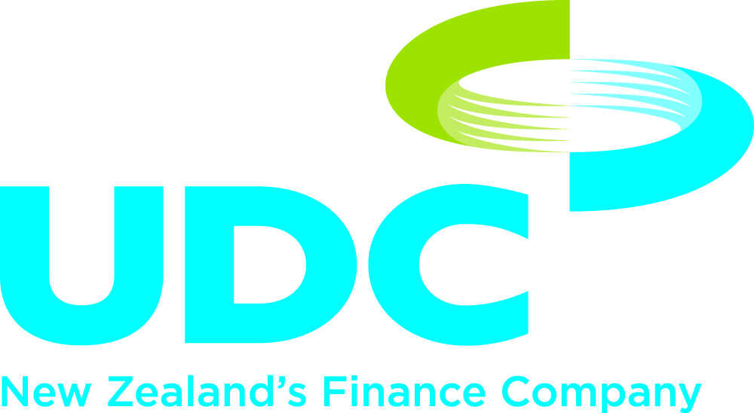
Credit Fees  Establishment Fee  This fee covers the cost of processing, assessing and approving your finance application. It will only be charged if your finance application is approved.  Dealer Fee  This fee covers the cost to the Dealer of preparing and processing your application for finance.  PPSR  This is the cost to us of searching and registering a security interest on the Personal Property Security Register.  Statement  Charged to your account when an additional statement is requested and delivered over and above any statement provided free of charge.  Maintenance  This fee will be charged to align with the frequency of your loan repayments and covers the cost of keeping your loan active.  Variation Fees  Variation of contract  Charged when a variation, assignment or an unscheduled part prepayment is completed. This fee is payable at the time UDC consents to the variation, assignment or part pre-payment.  Early settlement  If you repay your loan in full before the final payment, then two different fees are charged:  - A fixed fee to cover the cost of settling your loan.  - A variable fee to cover any loss derived from breaking the funding associated with your loan.  To find out more information on early repayment fees, please refer to the following fact sheet.  Collections Fees  Default interest charge  Default interest is calculated at the rate of 5% per annum plus the annual interest rate referred to in your contract. If you fail to make any payment on the due date default interest is payable on the overdue amount from the due date until the date UDC receives full payment of that overdue amount.  Dishonour fee  Charged when a scheduled loan payment is dishonoured by your bank or when an automatic payment fails. The fee is payable and will be debited to your account at the time the relevant payment was due.  Late payment fee  Charged when a scheduled loan payment is not made on time and remains unpaid for seven days. The fee is payable and will be debited to your account at the time the relevant payment was due.  Repossession action fee  Payable in the event UDC commences repossession of the asset(s) taken as security. This fee will be debited to your account at the time repossession action is commenced.  Post repossession fee  This fee is payable and will be debited to your account after realisation of the assets or abandonment of realisation.  Interest Rates  Interest rates vary from 11.95% to 15.95%  These fees are effective from 1 August 2012. | $260.00  $250.00  $13.00  $5.00  $5.00 per month  $350.00  $270.00 plus a variable amount  5% p.a. plus the annual interest rate stipulated in your contract  $45.00  $45.00  $75.00  $100.00

